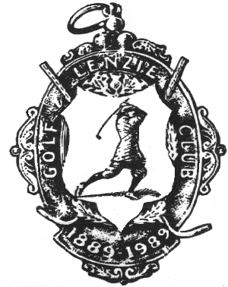
LENZIE GOLF CLUB
Lenzie Junior Open Tournament
incorporating the Cameron Penman Memorial Team Trophy.

Sunday 19th August 2018

Tee-off times are between 10.00am and 2.00pm

Scratch Competition
and

Under 18 & Under 14 Individual Handicap Competitions.
Girls Handicap max. 36. Boys Handicap max. 28.

Cameron Penman Team Trophy. Best 3 nett scores from one Club.

Participants should be under 18 or under 14 on 1st January 2018.

Online entries should be made via the LGC website. www.lenziegolfclub.co.uk

or

Hard Copy Entry Form

Home Club | Convener / Organizer | Tel. No:

Name of Entrant | CDH-ID | D.O.B. | H’cap | £5 Entry

Hard copy Entry Forms with S.A.E. should be submitted to the Match Secretary
Lenzie Golf Club
19 Crosshill Road
Lenzie
Glasgow G66 5DA

Entry Fee can be submitted for individuals or teams. Cheque payable to Lenzie Golf Club.

For confirmation of your Tee Time phone LGC (0141 776 1535) from Wednesday 15th August 2018.

