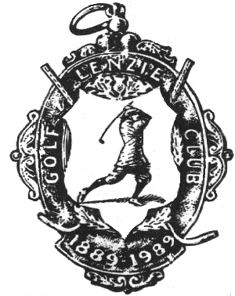
LENZIE GOLF CLUB
Lenzie Junior Open Tournament
incorporating the Cameron Penman Memorial Team Trophy.

Sunday 19th August 2018

Junior Open Prize Vouchers
Scratch Under 18 nett Under 14 nett
- £100.00. £100.00. £100.00.

- £50.00. £50.00. £50.00.

- £25.00. £25.00. £25.00.

Cameron Penman Memorial Team Trophy

Trophy & Titleist Awards.

Nearest the Pin Prize

Mizuno Golf Bag.

TOURNAMENT SPONSORS

Specsavers Kirkintilloch Town & Country Lenzie

Titleist

Fleming Buildings Ltd GolfKings

Mizuno Corporation (UK) Ltd

Old Gatehouse Lenzie Da Carlo Lenzie

Arnold Clark Lenzie First Class Catering

Golden Pheasant Bar and Restaurant

SNJ Recruitment Ltd

Jim McCallum Professional Lenzie Golf Club

