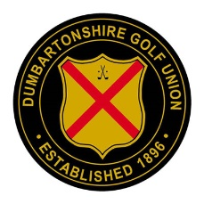
DUMBARTONSHIRE GOLF UNION
JUNIOR CLUB LIAISON OFFICERS 2020
CLUB EXECUTIVE MEMBER
Balmore Frank Gloag
Bearsden Alan Bell
Cardross Graham Smith
Clober Sam Bolton
Clydebank & District Jim Devaney
Clydebank Overtoun Jim Devaney
Douglas Park Sam Bolton
Dullatur John Struthers
Dumbarton Bob Provan
Hayston Jim Paton
Helensburgh Graham Smith
Hilton Park Frank Gloag
Kiirkintilloch Jim Paton
Lenzie Billy Hannah
Milngavie Alan Bell
Palacerigg John Struthers
Radnor Park John Struthers
Ross Priory John Struthers
The Carrick John Struthers
Vale of Leven Graham Smith
Westerwood Iain Orr
Windyhill Iain Orr

